**Library Management System**

**Data Model and ERD**

**CS 157A - Team #22**

Michael Leonard

Nicholas Papano

Sarah Saber

Entities and their attributes:

* USER : A user is any person that will use the system. There are two types of users, library customers and library employees. All users have the following attributes:
  + Library card number
  + Email
  + Name
  + Password
* CUSTOMER: A CUSTOMER is a type of USER. Customers have an account start/expiry date, and can have fines for overdue books.
  + Account start date
  + Account expiry date
  + Fines on account
* LIBRARIAN: A LIBRARIAN is a type USER. Librarians have additional attributes such as a start/hire date and a pay rate.
  + Hire/volunteer start date
  + Pay
* ITEM : An ITEM is any item in the library inventory that can be loaned to customers. All items have the following attributes:
  + Call number
  + Genre
  + Status (available, on hold)
  + Late fee
  + Donated
  + Loan period
  + Purchase Price
  + Release date
  + Name
* BOOK: A BOOK is a type of ITEM. Books have additional attributes for author
  + Author
* MOVIE: A MOVIE is a type of ITEM. Movies have additional attributes for the following:
  + Director
  + Actor

Relationships and their attributes

* USER borrows ITEM: Users borrow items from the library. This relationship records the information about which users have checked out which items. A currently borrowed item has the following attributes:
  + Borrow date
  + Due date
  + Return date
  + Number of renewals
  + Whether it’s overdue or not
* USER places a hold on ITEM: Users can place a currently borrowed item on hold, so that they can check it out when it returns. This relationship records the ID of the user placing an item on hold, the item being placed on hold, and the date it is due back.
  + Hold date
* USER adds ITEM to wish list: Users can have a wish list of items to check out in the future. This relationship records pairs of user IDs and item IDs to record the wish list for each user.
* LIBRARIAN generates REPORT that has ITEMs: Librarians can run a report to collect information about item status for all library inventory. These reports include the following information:
  + Num of items on hold
  + Num of overdue items
* LIBRARIAN adds ITEM to inventory: Librarians can add books to inventory. This relationship records pairs of item call numbers and librarian card numbers

ISA:

* BOOK ISA ITEM
* MOVIE ISA ITEM
* CUSTOMER ISA USER
* LIBRARIAN ISA USER

**ERD**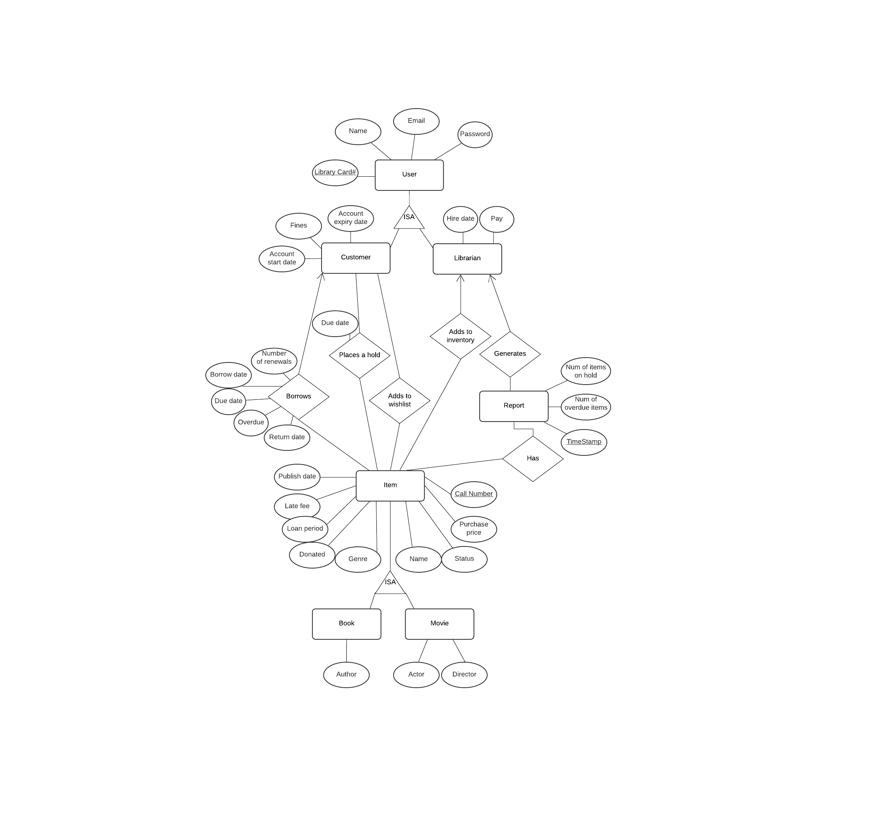

Tables:

User(LibraryCardNumber, firstName, lastName, email, password)

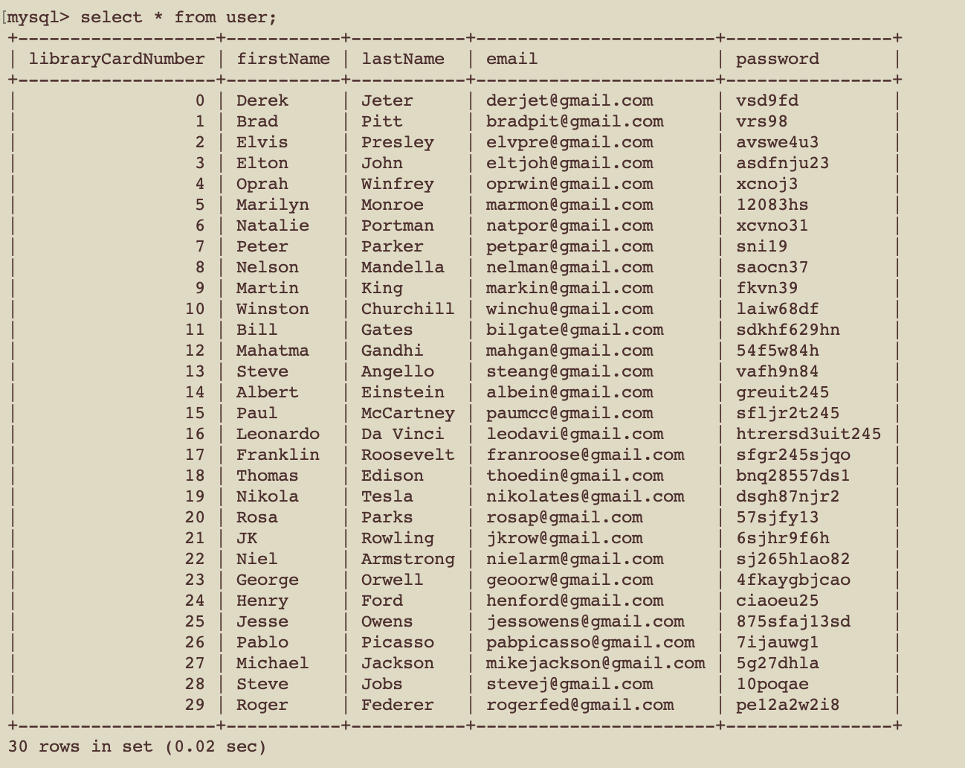

Customer(LibraryCardNumber, accountStart, accountExpiry, fines)

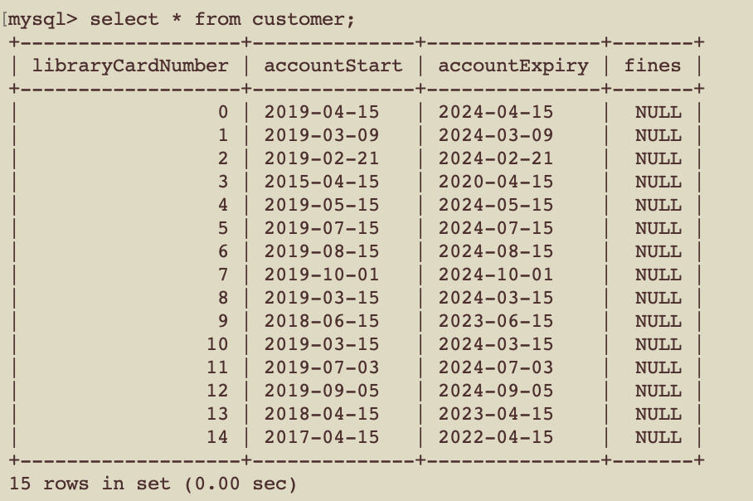

Librarian(LibraryCardNumber, hireDate, pay)

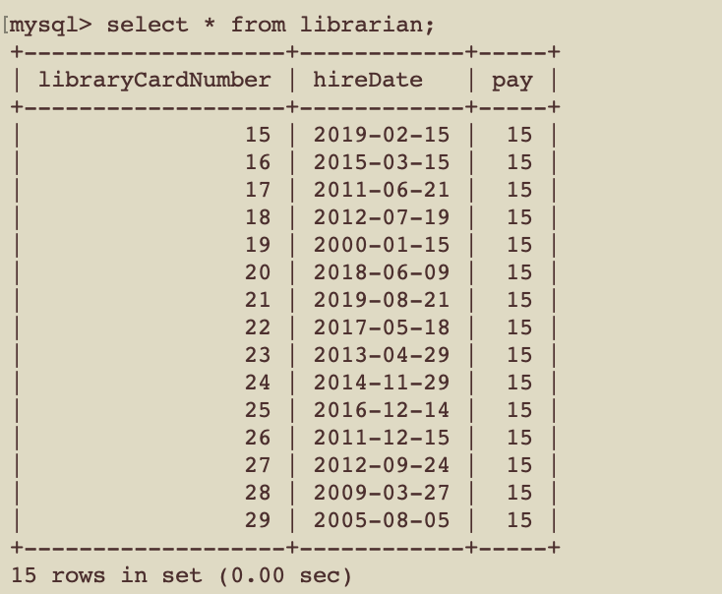

Item(callNumber, purchasePrice, donated, status, genre, name, releaseDate, loanPeriod, lateFee)

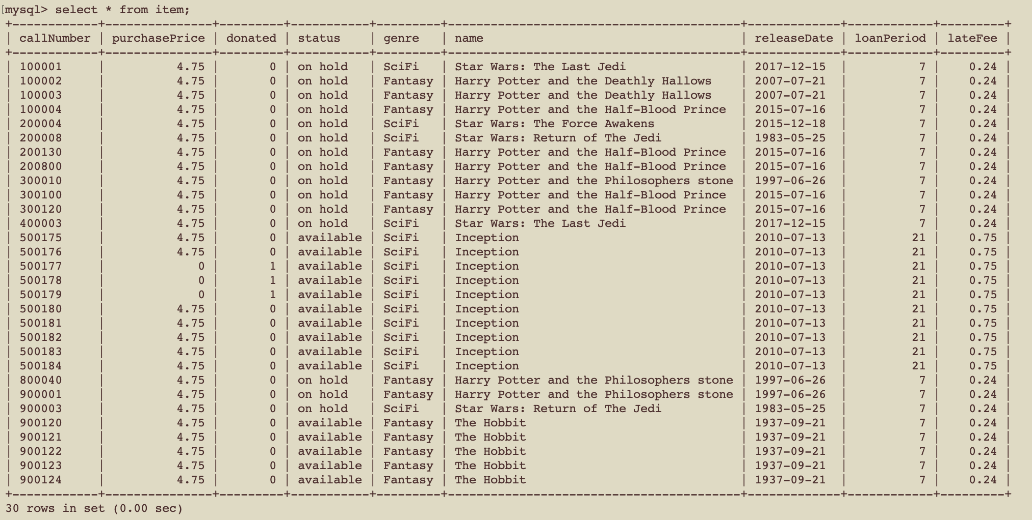

Book(callNumber, author)

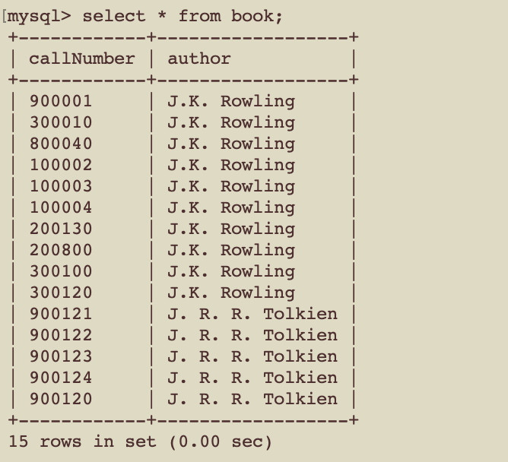

movie(callNumber, actor, director)

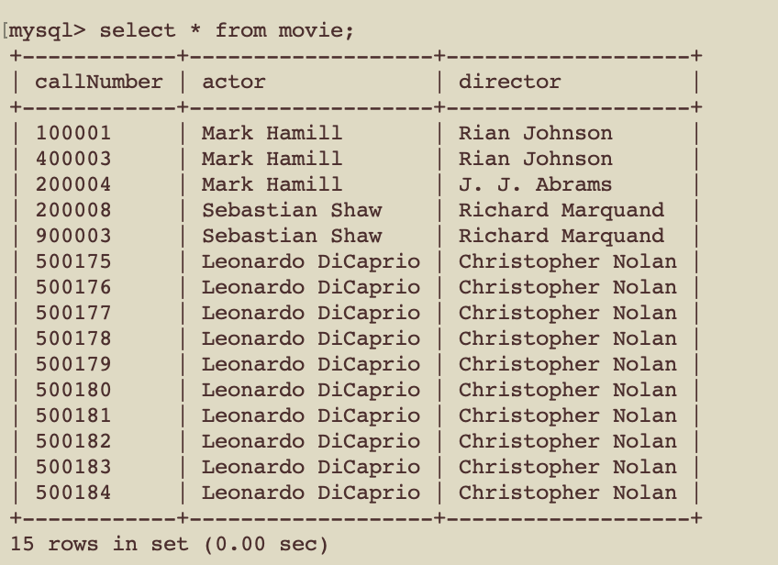

hold(holdDate, callNumber, libraryCardNumber)

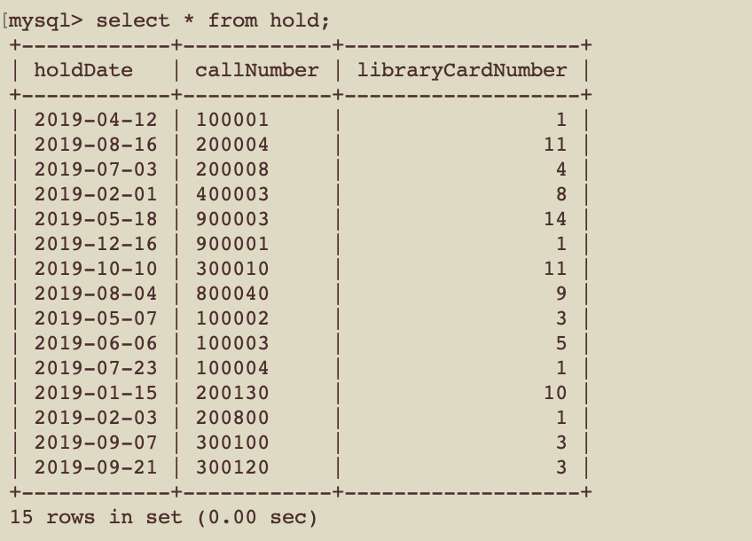

wishlist(callNumber, libraryCardNumber)

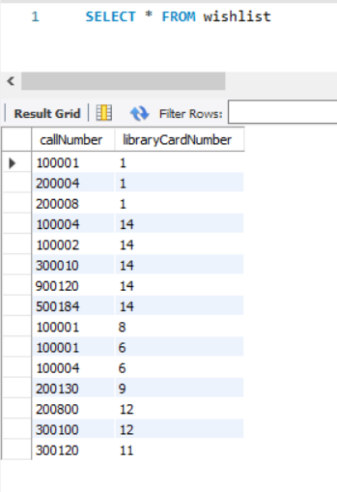

borrows(borrowDate, dueDate, overdue, returnDate, numberRenewals, callNumber, libraryCardNumber)

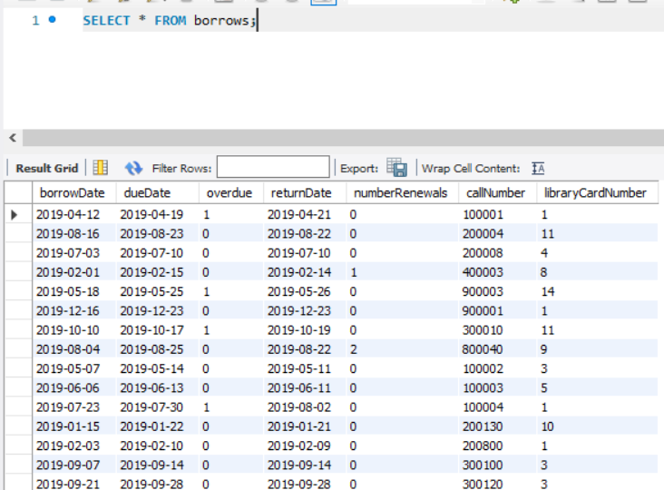

addToInventory(callNumber, libraryCardNumber)

